Verilog
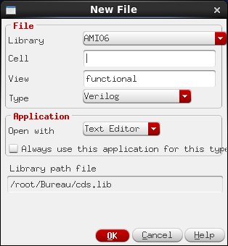

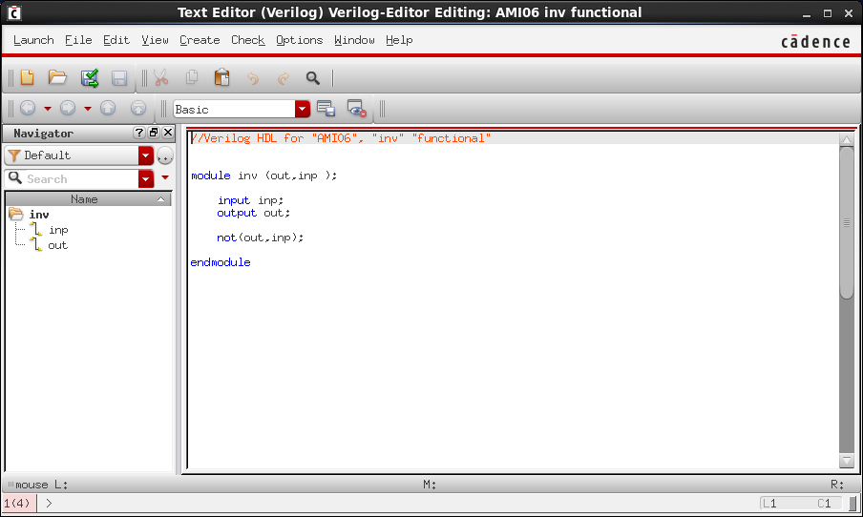

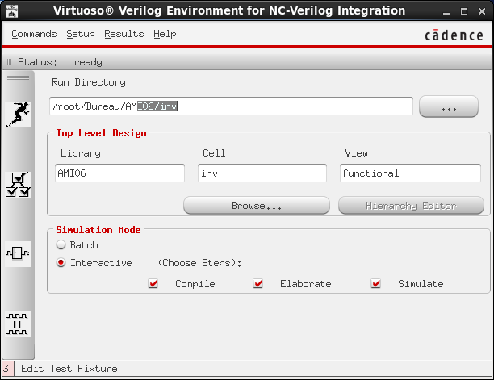

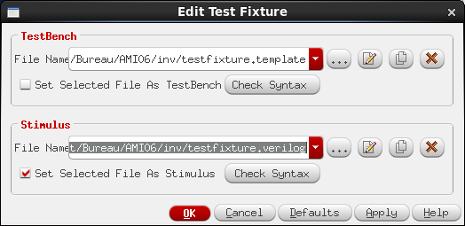

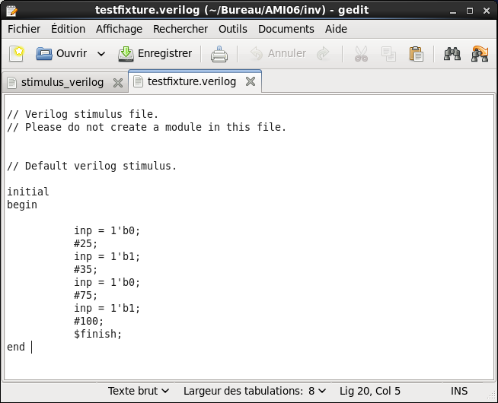

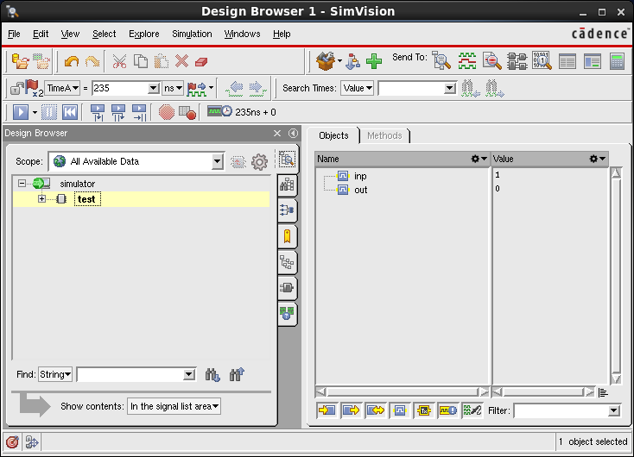
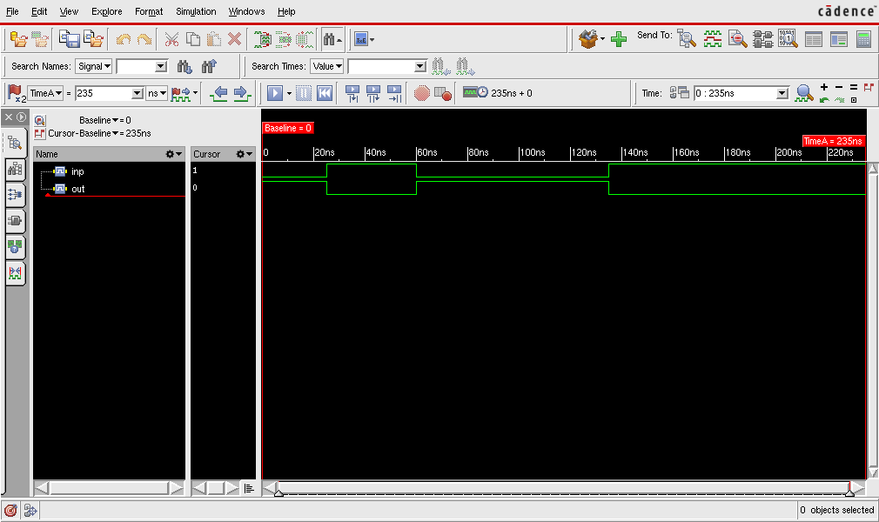

VerilogA
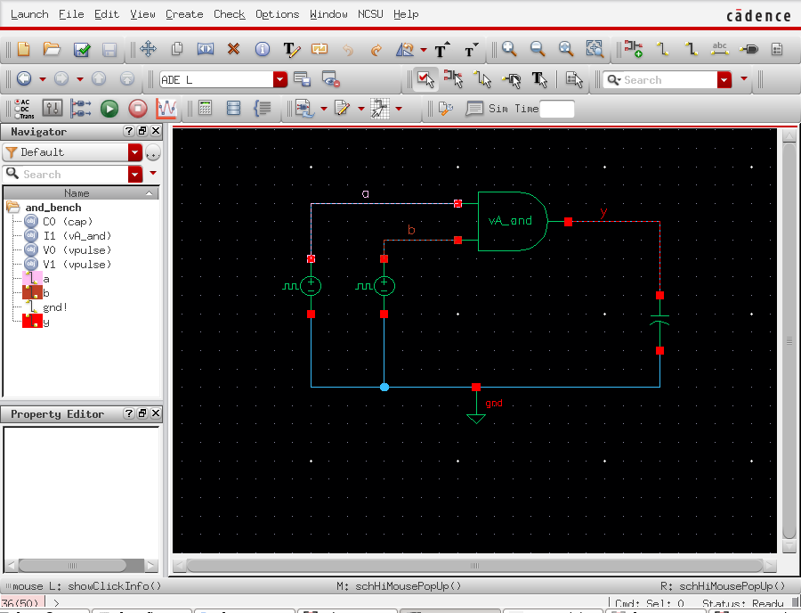

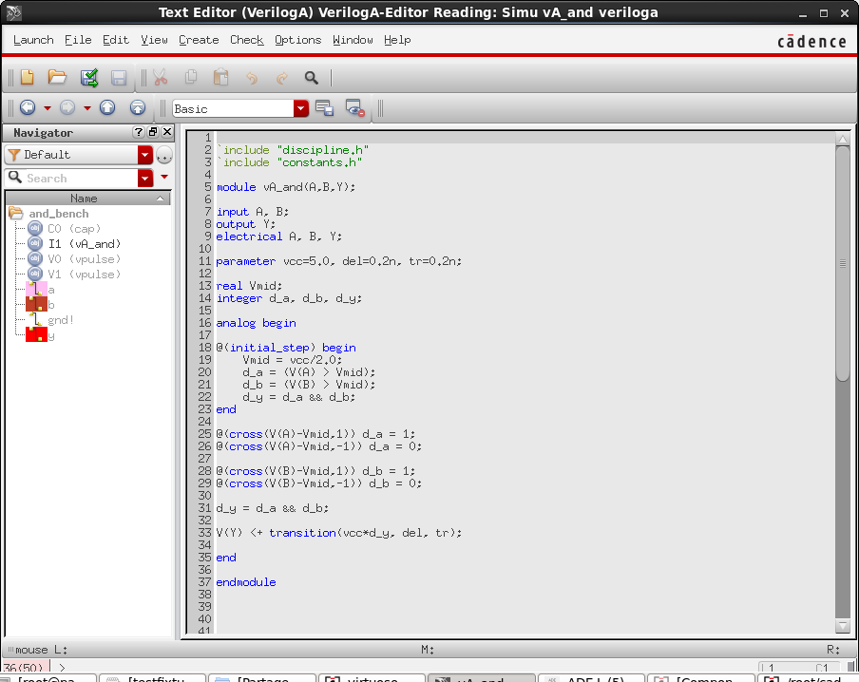
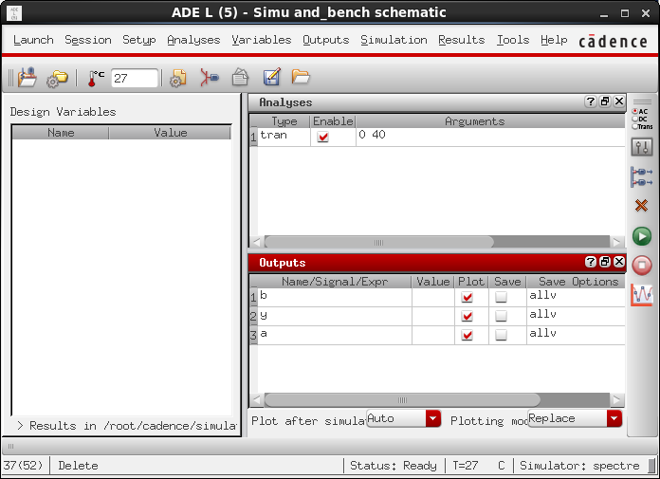

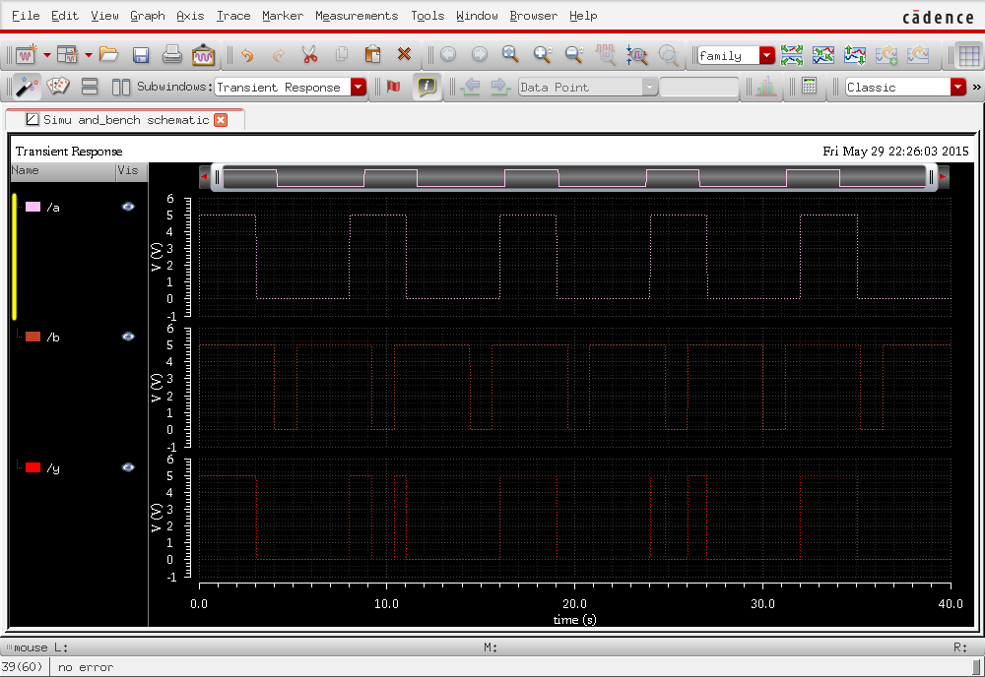
The Sizing Rules Method for Analog Integrated Circuit Design

The gm/ID Methodology, a sizing tool for low-voltage analog CMOS Circuits ...
Par Paul Jespers

Structured Analog CMOS Design
Par Danica Stefanovic,Maher Kayal

sizing W/L cmos differential pair

http://www.edaboard.com/thread81185.html

How to choose the W/L of OPAMP differential pair

CMOS Analog Design Using All-Region MOSFET Modeling
Par Márcio Cherem Schneider,Carlos Galup-Montoro

- How to calculate W/L ratio for given current

Design of CMOS Operational Amplifiers
Par Rasoul Dehghani

he gm/ID Methodology, a sizing tool for low-voltage analog CMOS Circuits
jasper

Design of Low-Voltage, Low-Power Operational Amplifier Cells

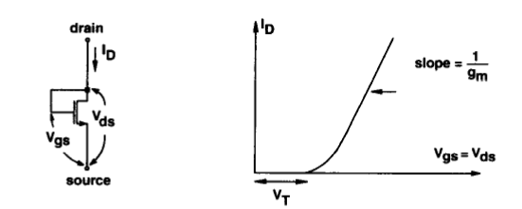
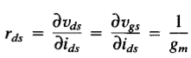 car VDS = VGS

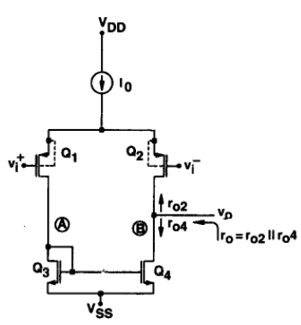
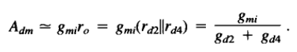
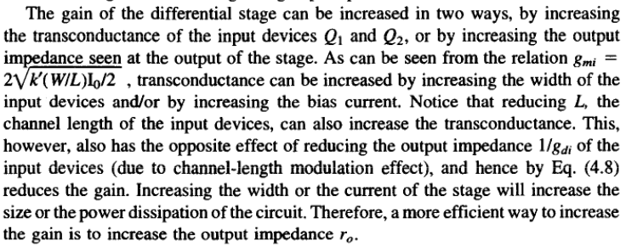

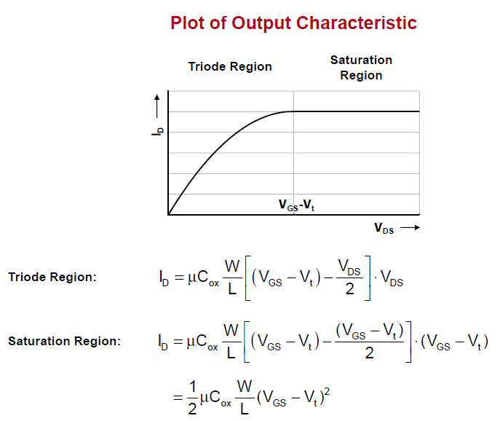

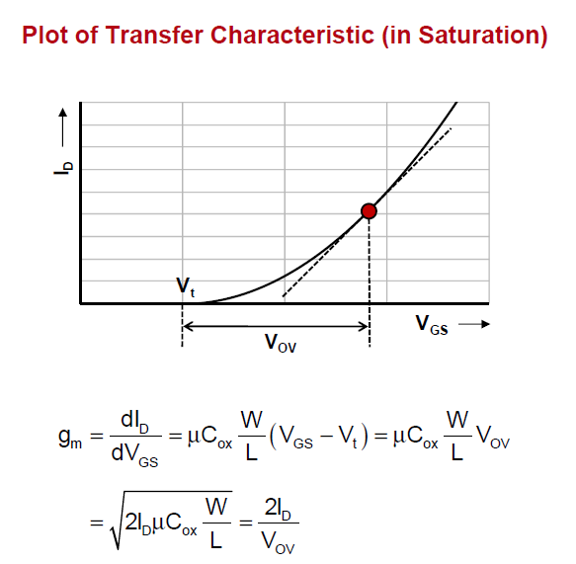
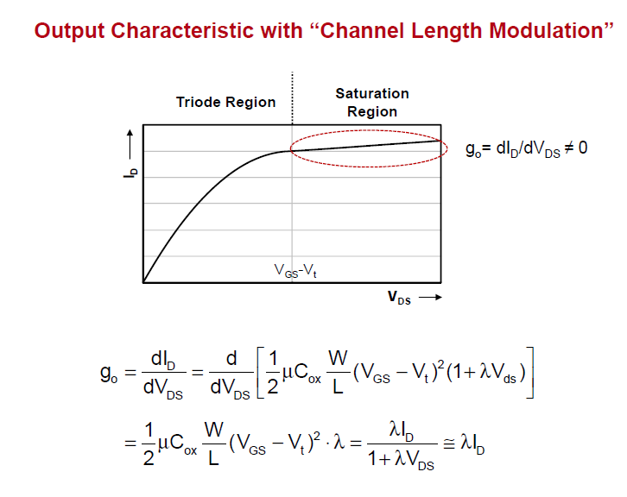

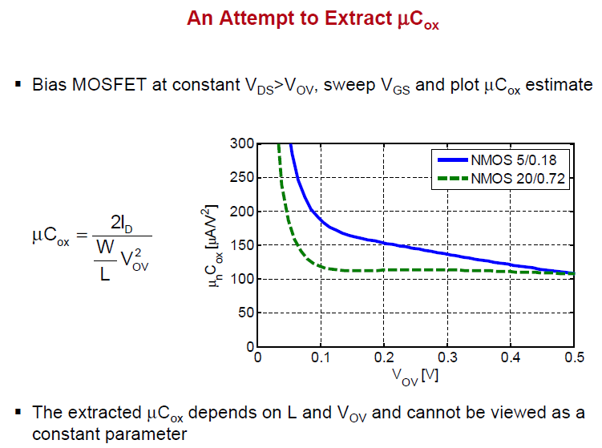
The channel-length-modulation effect typically increases in small devices
Channel length modulation is more pronounced in short channel devices.
In short channels, the drain-junction depletion region presents a larger fraction of the channel, and the channel-modulation effect is more pronounced. That’s why long channel transistors are used when high-impedance current sources are designed.
Transistors with long L are used to approximate square law and reduce channel length modulation effect. Large transistors are employed to improve matching
Assume a “Long Channel” device (for now do not worry about the channel length modulation effect)

How to choose the W/L of OPAMP differential pair

How to choose optimum length for op-amp design?

Flicker noise is proportional to (WL)−1

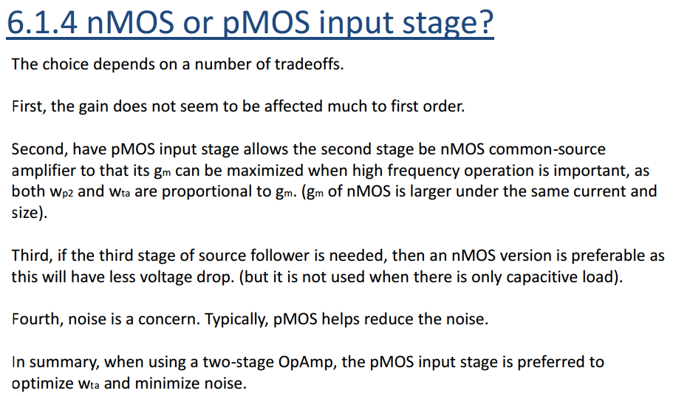

A longer L also reduces current-mirror mismatches.

The Sizing Rules Method for Analog Integrated Circuit Design

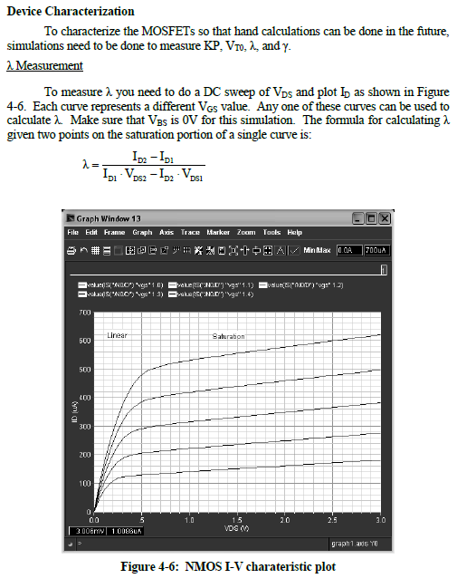

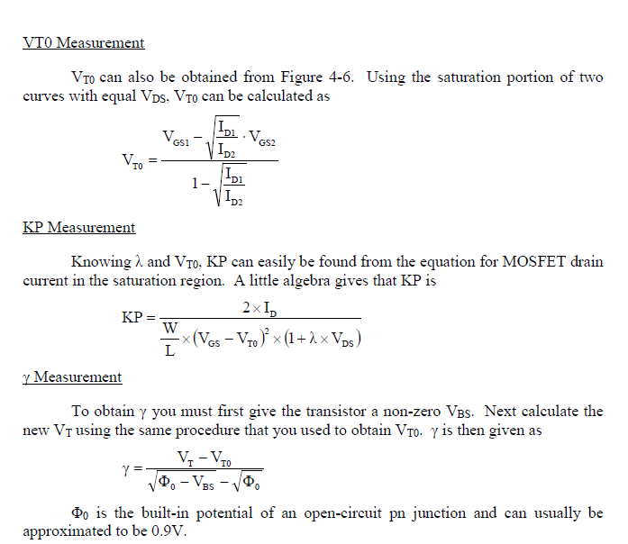

Process Data for AMI06 process

Parameter (unit) | Value  (NMOS) | Value  (PMOS)
W Minimum (cm) | 1.5x10⁻⁴ | 1.5x10⁻⁴
L Minimum (cm) | 0.6x10⁻⁴ | 0.6x10⁻⁴
TOX (cm) | .014x10⁻⁴ | .014x10⁻⁴
CGDO (F/cm) | 1.99x10⁻¹² | 2.4x10⁻¹²
CGSO (F/cm) | 1.99x10⁻¹² | 2.4x10⁻¹²
CJSW (F/cm) | 3.85x10⁻¹² | 3.11x10⁻¹²
CJ (F/cm²) | 4.23x10⁻⁸ | 7.27x10⁻⁸
VT (V) @ Ln =0.6x10⁻⁴ | .6 | -.82
KNP /KPP A/V² | 46.3x10⁻⁶ | 30x10⁻⁶
Length of Source or Drain (cm) (D_{D}) | 1.5x10⁻⁴ | 1.5x10⁻⁴
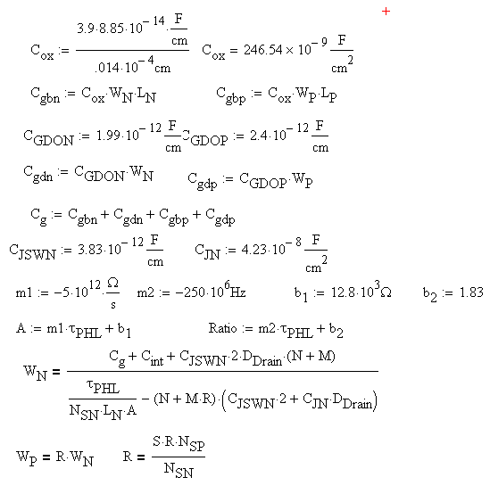

Rout = 1 / (lambda*Id)

Cadence: Characterizing MOSFETs

https://vlsi.engr.uidaho.edu/
http://www.32mosfets.com/cadence/cadence-tutorials/plotting-mosfet-characteristics/id-vgs/
λ=sqrt(2ε/qNa) / (2*L*sqrt(Vds-Veff+phi))
ε = permitivity of the substrate
q = electron charge
Na = impurity concentration of the substrate
L = length
Veff = Vgs-Vt
phi = built in potential between diffusion and substrate
Gds = 1/r0 , where r0= 1/ (lambda*Id).

Lambda : the channel-length modulation parameter: de 0.005 à 0.03

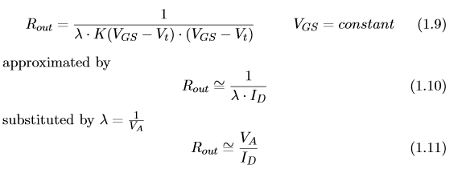

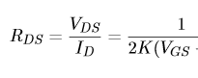

http://personalpages.to.infn.it/~cobanogl/lowlevelstuff/tutparext2/
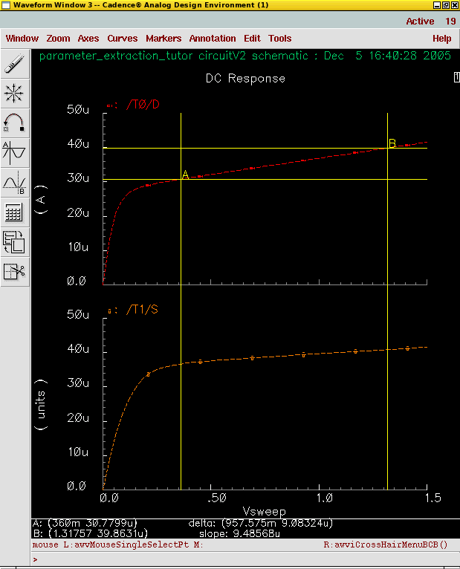

If you are in strong inversion you have to verify that: VDS >= VGS-VTH
If VDS >= VDSSAT then you are in saturation

you need to edit CDF (Component Discription Format) for your components.
Open CDF for nmos (pmos),
find "Interpreted Labels Information" chapter,
find line "opPointLabelSet" and add "vdsat"
Another method is as follows:
In the schematic window, select menu 'Edit/Label Display...', set the form entries:
Select Label: parameter
Apply To: cell
Then select a instance.
Set the form entries:
Operating Points
Then modifier the operating point variables to be displayed.
Add the parameters in your CELL CDF 'opPointLabelSet', e.g.
> opPointLabelSet = "id gm gds vdsat vds vth cgg cgd"
>
> 2. Add more 'cdsParam(n)' labels to your CELL symbol.

